* Get GNU Arm Embedded Toolchain
  + <https://developer.arm.com/tools-and-software/open-source-software/developer-tools/gnu-toolchain/gnu-rm>
  + Download from <https://developer.arm.com/tools-and-software/open-source-software/developer-tools/gnu-toolchain/gnu-rm/downloads> - get Win32-bit version …SHA2.exe, signed for Win 7 and later)
  + Install it. On last page (before “Finish”) select “Add path to environment variable”
* Configure MDK-ARM to use it
  + <http://www.keil.com/arm/gnu.asp>
  + <http://www.keil.com/support/man/docs/uv4/uv4_dg_prjfoldext.htm>
    - Folder: …-update\ (not bin etc.)
    - Add include file paths to Options/CC/Include Paths
    - Disable multi-line comment warning (allow C99)
    - Documentation at file:///C:/Program%20Files%20(x86)/GNU%20Tools%20ARM%20Embedded/8%202019-q3-update/share/doc/gcc-arm-none-eabi/html/gcc/index.html
* Change source code (C:\Users\Alex\Documents\Teaching\ESA\ESA-Fall-2019\Code\ESA-19\GNU\LCDs-Profiler-RTX5-CMSISv2) from Keil armcc5 to gnu syntax
  + #pragma noinline -> ?. file:///C:/Program%20Files%20(x86)/GNU%20Tools%20ARM%20Embedded/8%202019-q3-update/share/doc/gcc-arm-none-eabi/html/gcc/Inline.html#Inline
  + __align(4) int var -> int var __attribute__ ((aligned (4)) <https://gcc.gnu.org/onlinedocs/gcc-5.2.0/gcc/Variable-Attributes.html#Variable-Attributes>. Commented out: lucida_8x13.c, lucida_12x19.c
  + __current_sp() -> <https://gcc.gnu.org/onlinedocs/gcc-5.2.0/gcc/Return-Address.html#Return-Address>. _builtin_frame_address()? Getsp? Commented out in timers.c
* Looking for start-up code for GNU
  + <https://github.com/ErichStyger/mcuoneclipse/tree/master/Examples/Eclipse/FRDM-KL25Z/FRDM-KL25Z_GNU_Arm_Eclipse/startup> and <http://mcuoneclipse.com/2013/12/23/diy-free-toolchain-for-kinetis-part-7-gnu-arm-eclipse-plugins/>
* And the linker file too (.ld)
* Can CMSIS, RTXv5 and GCC work together?
  + Can build CMSIS components with GCC, but not Keil Middleware. <http://www.keil.com/support/docs/4130.htm>
  + <https://sergeev.io/notes/cortex_cmsis/>
* Sbrk missing… <https://answers.launchpad.net/gcc-arm-embedded/+question/246883>

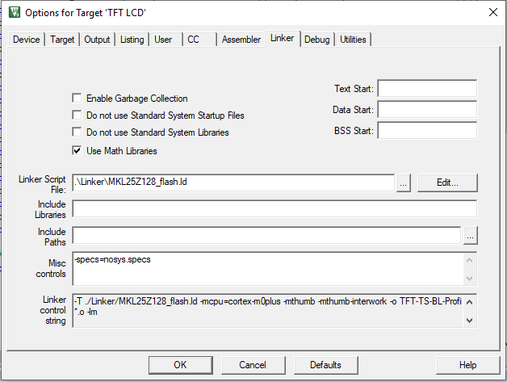

* Download button disabled. Had to update utilities tab to use debugger settings to enable it
* Code sort of works
  + Starting tone plays very slowly, repeating cycle.
  + Where do I set the stack size?